Reindeer Chow

Santa's reindeer get hungry on Christmas Eve, too. You can make this festive variation on the classic "puppy chow" for an easy treat for the kids to set out for them.

By Bakerella
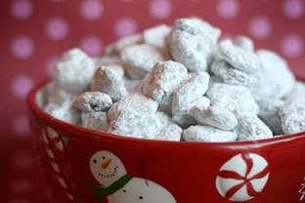

Ingredients

- 5 cups Crispix cereal
- 1 cup peanut butter
- 1 12-ounce package of semisweet chocolate morsels
- 1 box confectioners' sugar
- Melt chocolate in the microwave one minute at a time until melted, stirring in between.
- Add peanut butter to melted chocolate and mix well.
- Place cereal in a large bowl (with a snap-on lid).
- Add melted chocolate and peanut butter to the top of cereal and mix well.
- Add confectioners' sugar and cover the bowl with a lid. Shake well to coat thoroughly.
Note: If you don't have a bowl with a lid, you can place the coated cereal and confectioners' sugar in a large resealable plastic bag and shake well.
Taken from http://www.cookiemag.com/food/2008/11/reindeer-chow

